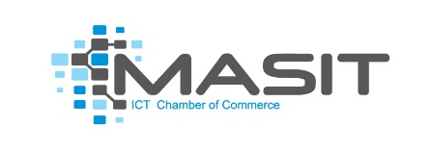

Expression of interest template
Basic information about company:
Company name
Company address (street number, city, country)
Company size (Micro 1-5 small 5-50 medium 50-250) | ☐ Micro (1-5 employees)  ☐ Small (5-50 employees)  ☐ Medium (50-250 employees)
Company website (if applicable)
Type of industry (select) | ☐ agriculture and processing,  ☐ apparel and textiles,  ☐ wood processing,  ☐ tourism (eco-tourism, rural tourism, and adventure tourism)
Number of employees | Full time:  Part time:
Company profile / description
Contact person | Name:  e-mail address:  phone number:
Detailed information about the company:

Does the company have a current business / operational / marketing plan?
Did the company or its employees attend any ICT related trainings or certification process? If yes, please specify
Is the company currently promoting or distributing products/services online?
Is the company working on domestic and /or international market?
Is the company currently developing new service/product?
Is the company willing to invest in IT solutions for improving the business operations?

On behalf of the company that I represent, I confirm the interest and commitment to be involved in project "Digitalization path" implemented by MASIT / STIKK / ICT Net as a beneficiary company and to work diligently with the experts who will be in charge of defining the Digital Transformation Strategy in accordance with mutualy set work dynamics.

Signature
_______________

